ARRIVAL after BREAKFAST 7:45 – 7:50
All students will:  -Bring home and back to school their PURPLE Take Home Folder daily  -Sign in for lunch, Hang backpack  -Have a seat and begin Silently Reading |  | The teacher will:  -Check folders for notes and important info  -Check attendance/take lunch information  Greeting: Students and teachers greet one other by name and practice offering hospitality.
**SPECIAL AREA ROTATION every SIX DAYS**
Time: 7:55 a.m. – 9:20 a.m.
Day 1: Class/PE
Day 2: Music/Media
Day 3: Dance/STEM
Day 4: Ag/Drama
Day 5: Class/Puppetry
Day 6: Art/Computer
MORNING WORK
Good Morning, Sunshine
Grammar Exercises
Greek & Latin Roots
Daily Cursive Writing
Interactive Notebook Reference Pages for ELA and WRITING
Kindness 101
LITERACY BLOCK
ELA
ELA BENCHMARK STANDARDS | Informative Writing |  | Benchmark Aligned Questions
ELA.5.V.1.3 Use context clues, figurative language, word relationships, reference materials, and/or background knowledge to determine the meaning of multiple-meaning and unknown words and phrases, appropriate to grade level.  ELA.5.V.1.1 Use grade-level academic vocabulary appropriately in speaking and writing.  ELA.5.F.1.4 Read grade-level texts with accuracy, automaticity, and appropriate prosody or expression.  ELA.5.R.3.2 Summarize a text to enhance comprehension.  Include plot and theme for a literary text.  ELA.5.R.1.1 Analyze how setting, events, conflict, and characterization contribute to the plot in a literary text.  ELA.5.R.1.3 Describe how an author develops a character’s perspective in a literary text.  ELA.5.R.2.2 Explain how relevant details support the central idea(s), implied or explicit.  ELA.5.V.1.3 Use context clues, figurative language, word relationships, reference materials, and/or background knowledge to determine the meaning of multiple-meaning and unknown words and phrases, appropriate to grade level.  ELA.5.R.2.1 Explain how text structures and/or features contribute to the overall meaning of texts.  ELA.5.R.3.1 Analyze how figurative language contributes to meaning in text(s).  ELA.5.R.1.2 Explain the development of stated or implied theme(s) throughout a literary text. | Students are writing a text-based informative essay and graded on all five sections. The Final Copy will be a summative grade.  “YouTube in the Classroom”  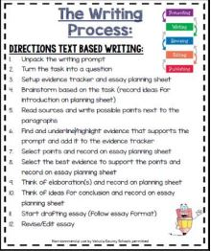 |  | - What is the central idea(s) of the text?  - What relevant details support the central idea(s)?  - How do the relevant details support the central idea(s)?  - What is the text structure?  - How does the text structure contribute to the overall meaning of the text?  - What text features are present in the text? How do the text features contribute to the overall meaning of the text?  - How does the author’s use of the _____ type of text structure contribute to the overall meaning of the text(s)?  - How does the author’s use of the _____ text feature contribute to the overall meaning of the text(s)?  “The Banners of Freedom”  “Road to Revolution”
BENCHMARK STANDARDS | WRITING |  | Social Studies
ELA.5.C.1.4 Write expository texts about a topic using multiple sources and including an organizational structure, relevant elaboration, and varied transitions.  ELA.5.C.1.5: Improve writing by planning, revising, and editing, with guidance and support from adults and feedback from peers.  ELA.5.C.2.1: Present information orally, in a logical sequence, using nonverbal cues, appropriate volume, clear pronunciation, and appropriate pacing.  ELA.5.C.3.1: Follow the rules of standard English grammar, punctuation, capitalization, and spelling appropriate to grade level.  ELA.5.C.5.2: Use digital writing tools individually or collaboratively to plan, draft, and revise writing.  ELA.5.F.1.3 Use knowledge of grade-appropriate phonics and word-analysis skills to decode.  ELA.5.V.1.3 Use context clues, figurative language, word relationships, reference materials, and/or background knowledge to determine the meaning of multiple-meaning and unknown words and phrases, appropriate to grade level.  ELA.5.F.1.4 Read grade-level texts with accuracy, automaticity, and appropriate prosody or expression. | Write an Expository Essay  Types of Hooks/Introductions:  Strategies to grab the reader’s attention:  List, Question, Quotation, Definition, Description, An interesting Fact, Surprising Statement, Background Information, Cause/Effect Relationship, Restate the Prompt (use if you are stuck!)  Avoid using phrases like these:  My name is…  Once upon a time...  This essay is about…  I am going to tell you about…  Types of Endings/Conclusions:  Strategies for a final thought/closure:  Advice, Action, Question, Challenge, Inference, Quotation, Prediction, Recommendation, If/then Statement, Further Exploration  Avoid using phrases like these:  The end…  Bye…gotta go now!  That’s all I can think of…  Hope you enjoyed reading…  ” |  | SS.5.A.3.1: Describe technological developments that shaped European exploration.  SS.5.A.3.2: Investigate (nationality, sponsoring country, motives, dates and routes of travel, accomplishments) the European explorers.  SS.5.A.3.3: Describe interactions among Native Americans, Africans, English, French, Dutch, and Spanish for control of North America.  SS.5.A.4.1: Identify the economic, political and socio-cultural motivation for colonial settlement.  SS.5.A.4.2: Compare characteristics of New England, Middle, and Southern colonies.  SS.5.A.4.3: Identify significant individuals responsible for the development of the New England, Middle, and Southern colonies.  SS.5.A.4.4: Demonstrate an understanding of political, economic, and social aspects of daily colonial life in the thirteen colonies.  SS.5.A.4.5: Explain the importance of Triangular Trade linking Africa, the West Indies, the British Colonies, and Europe.  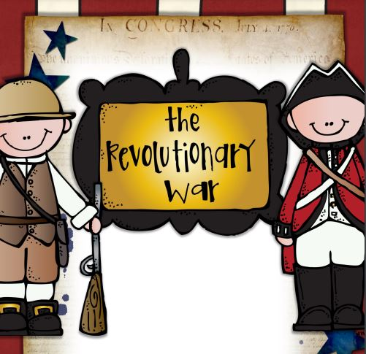
County Writing Test Tuesday 2.27  Final Copy of You Tube Writing due 2/29 |  |  | UPCOMING DATES  2/12-2/16: Kindness Week  2/15: 5th Grade Science Fair  2/19: No School!  2/27: Board Meeting 6 pm  2/28: Talent Show Auditions  3/1: PAC Ice Cream  3/1: Dress Down Day is now “Favorite Character Day”
RECESS/LUNCH
11:55-12:45 p.m.
WRITING BLOCK 2, ELA BLOCK 2, SOCIAL STUDIES 2
12:45 – 2:55 p.m.
DISMISSAL
3:00

